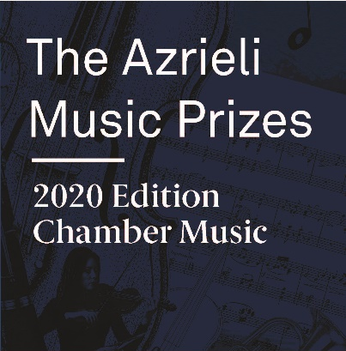
2020 AMP Performance Fund
Proposal Form

Thank you for making a proposal to the Azrieli Music Prizes Performance Fund.

Please complete this form and send it with the required attachments described below to music@azrieifoundation.org on or before the deadline of April 10, 2020.
Proposals are reviewed by AMP staff for eligibility and completeness on a rolling basis. Qualified submissions will be forwarded to the AMP Advisory Council for review prior to their Summer 2020 meeting. Decisions regarding which proposals will receive support from the Performance Fund will be communicated approximately two months after the application deadline.
For more information, please refer to the AMP Performance Fund application guidelines on the Azrieli Foundation website at www.azrielfoundation.org/amp.

Contact Information

Legal Name of the Ensemble
Incorporation Status /
Incorporation Number
Number of years in operation
Name of Artistic / Musical Director
Name of Managing Director / General Manager
Name and title of person completing this application
Contact information:
Phone Number
E-mail
Postal Address
The Proposal
When and where will you perform the AMP work(s)?
Which AMP work(s) are you choosing to perform?
If required, which soloist(s) will perform the work(s)?
How will the AMP Performance Fund support be used?
What other works will appear on the concert program with the AMP work(s)?

How does this proposed concert fit into your concert season?
How does this concert help advance the objectives of the
Azrieli Music Prizes?

Please attach:
- Organizational Documents:
  - Brief bios for your administrative and artistic senior leadership
  - Financial statements for your most recently completed fiscal year
  - A budget for the year in which the AMP work(s) will be performed
  - A concert budget showing the amount requested from the AMP Performance Fund (not to exceed $25,000 CAD)
- Artistic Documents:
  - Print record of both the past concert season and the current season’s programming;
  - Audiovisual recordings of two contrasting, recent examples of your ensemble performing contemporary musical works
    - Accepted formats are MP3, WAV, MP4 and MOV
  - Please indicate below the work information:
Work 1 | Work 2
Title: | Title:
Composer: | Composer:
Duration: | Duration:
Performance Date: | Performance Date:

- Optional: Letters of Reference
  - No more than two letter of reference from individual who can speak to your ensemble’s ability to undertake the proposed concert

Thank you for your proposal

